# DIGITAL SOLVER

## Game Overview

### Game Statistics

* Genre: 2D Platformer
* Players: 1
* Possible Game Engine: GDevelop

### Vision Of the Game

* The target audience for this game is for those wishing to learn a bit or re-learn some skills in a more interactive manner.
* This can also be shown to those who seem to believe that video games do not help out in this type of context or method.

### Intended Learning Objectives

* The game’s learning objectives will be focusing on giving the person an understanding of basic and some advanced concepts that are usually learned in educational areas.
* It won’t be forgotten either that it is a game and will still have techniques taught to the player that will assist them during the entirety of the video game.

### How This Will Be Achieved

* At the first part of the game, the learning will start out small and never try to overwhelm the player with too much.
* The game will also have tips and give vital information as well the more the player progresses through it all.
* As the progression increases, the content provided will also become more advanced.

### Gameplay Loop

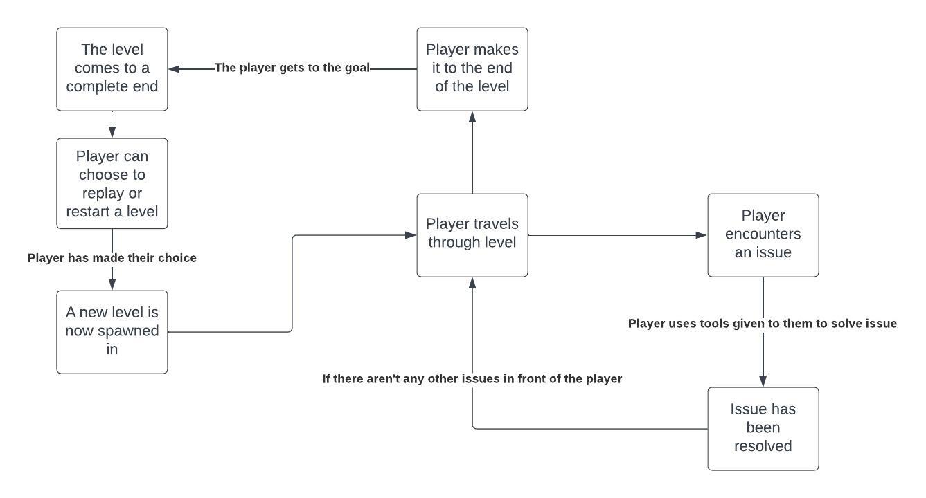

### How the Gameplay connects to the Learning Objective

* The game itself will give the player a few showcases of what they would be learning about as the level begins.
* If the player is incorrect or cannot get through a certain obstacle, the game will help out the player and tell them what needs to be done or what was wrong with their actions as it relates to their learning and understanding.

### Concept Art

Similar to one of the games I am working in, this one will have a GUI in one of the corners of the screen to help keep track of what the player has at their disposal and what their current condition is.

There will also be notes within the game similar to this that will help the player. These will pop in and out at times to not take up the entire screen or block the player’s view at any time during their experience.